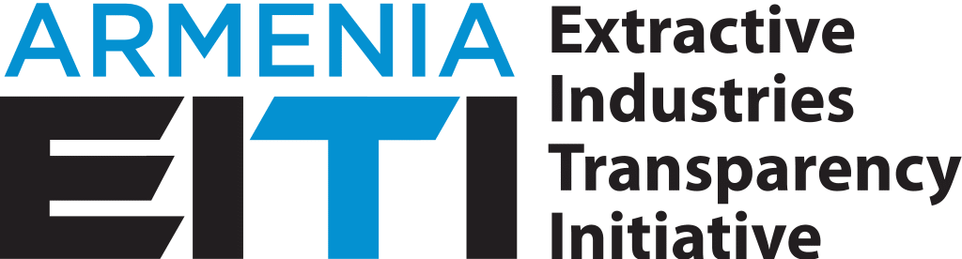

EXTACTIVE INDUSTRIES TRANSPARENCY INITIATIVE
MULTI-STAKEHOLDER GROUP

THE ROADMAP OF THE INTRODUCTION OF RESPONSIBLE MINING PRACTICES

December 2018
THE ROADMAP OF THE INTRODUCTION OF RESPONSIBLE MINING PRACTICES
Guided by the principles of the Extractive Industries Transparency Initiative (EITI), the Multi-stakeholder Group (MSG) of the EITI Armenia envisaged to provide support for the introduction of responsible mining (hereafter RM) practices in Armenia as one of the most important components of sustainable development of the country and create a RM roadmap.
Taking into consideration the EITI Requirement 8, during the process of validation, in addition to evaluating the fulfillment of the requirements of the EITI Standard, the efforts made beyond the mandatory requirements will also be considered. These include efforts by the Multi-stakeholder Group to successfully achieve any workplan objectives that fall outside the scope of the EITI Standard, but have been identified by the multi-stakeholder group as necessary objectives for the EITI to address national priorities for the extractive sector. Accepting the potential of the EITI process also in providing support for the introduction of RM, within the framework of EITI in Armenia a general analysis of the mining sector legislation was ordered and conducted.
Realizing that the Government of Armenia has started a process of the development of a new Mineral Sector Policy, which should be preceded by two major diagnostic studies, as well as acting according to the approach of the EITI MSG of setting responsible mining as a priority in the sector, it is necessary to ensure maximal participation of the MSG Working Group on RM in the policy development process.
Having regard to the above statement, EITI Armenia’s MSG Responsible Mining Working Group undertakes to:
- develop “the EITI Armenia’s MSG’s approach on the responsible mining” concept paper, taking into account the controversial issues of the mining sector of Armenia and the international experience in the introduction of RM culture;
- provide opinions and suggestions within the framework of the following studies: “Economic Analysis of Armenia’s Mining Sector and its contribution to Sustainable Development” and “Environment and Health Analysis of Armenia’s Mining Sector as input to a new Mineral Sector Policy”, undertaken by RA Government with support of the World Bank;
- provide opinions and suggestions during the Mineral Sector Policy development process;
- present to the MSG the opinions on the main documents provided by the members of the Working Group as well.
Recognizing that the development of a common policy and the adoption of main directions for the development of the sector will require 1-2 years, we believe that the potential of the Working Group can also be used for the improvement of already circulated or new legal acts oand drafts.

THE TIMETABLE OF ACTIVITIES AIMED AT THE INTRODUCTION OF RESPONSIBLE MINING PRACTICES
ROADMAP ITEM | OBJECTIVE | ACTIVITIES | RESPONSIBLE |  | DEADLINE
EITI Armenia’s MSG Approach on the Responsible Mining” concept paper development | Giving definition or the scope of responsible mining based on the analysis of the issues related to the mining sector and study of international practices, where general directions and priorities of the responsible mining will be reflected. | 1.1 submitting proposals on the scope and directions of responsible mining by the MSG RM Working Group. | RM Working Group |  | January,  2019
 |  | 1.2 Conducting discussion on the collected proposals by the working group, preparation of the document and presenting to MSG. | Responsible Mining Working Group |  | February,  2019
 |  | 1.3 Approval of the Concept Paper by MSG | MSG |  | February-March,  2019
2.  Participation in the activities of the economic analysis of mining sector | As a key sector in the economy of the country, it is necessary to assess the real economic potential of the mining industry, assess the level of the effectiveness of economic management of mines management, the input of mines in the development of affected community. | 2.1 Providing opinions and suggestions on the brief overview of the study on “Economic Analysis of Armenia’s Mining Sector and its contribution to Sustainable Development” and in case of possibility participation in the discussion meetings on them. | Responsible Mining Working Group,  Ministry of Energy Infrastructures and Natural Resources |  | February-March,  2019
 |  | 2.2 Providing opinions and suggestions on the preliminary study on “Economic Analysis of Armenia’s Mining Sector and its contribution to Sustainable Development” and in case of possibility participation in the discussion meetings on them. | Responsible Mining Working Group,  Ministry of Energy Infrastructures and Natural Resources |  | April-May,  2019
 |  | 2.3 Providing opinions and suggestions on the final version of the study on “Economic Analysis of Armenia’s Mining Sector and its contribution to Sustainable Development” and participation in the discussion meetings on them. | Responsible Mining Working Group,  Ministry of Energy Infrastructures and Natural Resources |  | June-July,  2019
3.  Participation in the activities of Environment and Health Analysis of Armenia’s Mining Sector as input to develop Mineral Sector Policy | It is necessary to assess the environmental and health impacts mineral sector development poses to affected communities and workers, as well as analyzing current legal and regulatory framework and institutional capacities, identify existing gaps in some areas, such as water management, soil management, air quality management, mine legacy management, mining waste management, health impact assessment and etc. | 3.1 Submitting opinions and recommendations on the brief overview of the study on “Environment and Health Analysis of Armenia’s Mining Sector as input to a new Mineral Sector Policy” and in case of possibility participation in the discussion meetings on them. | Responsible Mining Working Group,  Ministry of Nature Protection |  | March-April,  2019
 |  | 3.2 Submitting opinions and recommendations on the draft study on “Environment and Health Analysis of Armenia’s Mining Sector as input to a new Mineral Sector Policy” and in case of possibility participation in the discussion meetings on them. | Responsible Mining Working Group,  Ministry of Nature Protection |  | May-June,  2019
 |  | 3.3 Submitting opinions and recommendations on the final version of the study on “Environment and Health Analysis of Armenia’s Mining Sector as input to a new Mineral Sector Policy” and participation in the discussion meetings on them. | Responsible Mining Working Group,  Ministry of Nature Protection |  | July-August,  2019
4.  Mineral Sector Policy Development | Supporting in the development of such a Mineral Sector Policy which will contribute to the long-term sustainable development of the country. | 4,1 Participation in the works of writing Terms of Reference for choosing Mineral Sector Policy Developing company. | Responsible Mining Working Group,  Ministry of Energy Infrastructures and Natural Resources |  | October,  2019
 |  | 4.2 Submitting opinions and recommendations on the brief overview of the document being processed (if applicable) and participation in the discussion meetings. | Responsible Mining Working Group,  Ministry of Energy Infrastructures and Natural Resources |  | 2020
 |  | 4.3 Submitting opinions and recommendations on the draft document and participation in the discussion meetings. | Responsible Mining Working Group,  Ministry of Energy Infrastructures and Natural Resources |  | 2020
Works with state bodies on the circulated and drafting of new legal acts. | Presenting legislative proposals based on the general logic of responsible mining concept paper. | 5.1 Monitoring legal acts and drafts related to the mining sector and submitting proposals to the working group with a view to submitting a petition with more concise arguments and substantiations. | Responsible Mining Working Group | ongoing

The deadlines of 2-nd, 3-rd and 4-th items will be conditioned by the actual implementation period of RA Government’s relevant activities wwithin the framework of the World Bank funded Grant No. TF0A5519 (Armenia Mineral Sector Policy) project.

